SHALOM PRIMARY SCHOOL
P.1 READING HOLIDAY WORK
TERM 1 2020.

NAME: ___________________________________________________ SCHOOL: _______________________________ STREAM: _____________

1. My name is _______________________________________________
2. My class is ________________________________________________
3. My school is ______________________________________________

4. Write the first letter sound only.
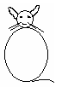___  ___ ___

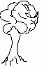___ ___

5. Read and draw pictures.
a. A woman on a mat

b. A man with a bag

6. Join and form words.
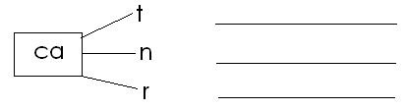
7. Match people to the places of work.
gatekeeper kitchen
cook classroom
pupils gate

8. Fill in the missing sound.
br ____ m sch ____l tr ____
sp ____ n r __ pe c____p

9. Use the words in the box to complete the story.

bag school car food

Aine goes to Shalom Primary _____________
She has a blue  _______________.

Her father drives a white ________________.
Her best _________________ is rice and meat.

10. What am I ?

a. I am round and yellow. I shine and give you light.
I am a _________________________________
b. I am made out of wood.
You find me in class and you sit on me.
I am a ________________________________

11. Use Yes, it is or No, it is not.
 Is this a book?
______________________________________________
Is this a flower?
_____________________________________________


Is this a chair?
_____________________________________________

Is this a pot?
______________________________________________

12. Complete the sentences correctly.
a. The first day of the week is ____________________________
b. _____________________is the last day of the week.
13. Write the words correctly.
gfla _____________________
dgeba _____________________

14. Write words with these sounds.
sh ______________ ee ____________________
oa ___________________ j __________________
ai ______________________ g ______________________

- Match pictures to their first letter sounds.
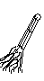 dr
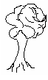 sh
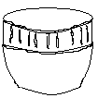
fl

tr

br

- Underline words with these syllables.
gra: green grass grain
bla: black boot box
sme: simon smell smart
pe: pilot pot pen
God is Love

